Event System How to Guide
1. Introduction - Top 2
2. Shift List Page - Top 2
2.1. Create an Shift List 2
2.2. Save an Shift List 4
2.3. Add a Comment 5
2.4. Add a One Time Event 6
2.5. Disable/Enable an Event 7
2.6. Editing a Comment 7
2.7. Update an Event 8
2.8. View Comment Data 9
2.9. View Performance Data 10
3. Event Management Page - Top 11
3.1. Duplicate an Event 11
3.2. Delete an Event 11
3.3. Disable/Enable an Event 12
3.4. Edit an Event 12
3.5. View an Event 13
4. Event Creation Page - Top 13
4.1. Create a New Event 13
4.2. Understanding Event Scheduling 14
4.3. View and Interpret Audit Data 15
4.4. View and Interpret Comment Data 16
4.5. View and Interpret Performance Data 18
5. Event Reporting Page - Top 19
5.1. View a Past Shift List from Audit Data 19
5.2. View a Past or Future Shift List 20
- Introduction - Top
The following document lays out how to perform various tasks organized by which system page is responsible for initiating the task; as well as, how to interpret some of the advanced features and information found inside the various windows embedded in each of the Event System Pages.
- Shift List Page - Top
  - Create an Shift List
- Navigate to the Shift List Page
- The page will show all events currently in the Shift List table, along with all relevant information – The page also has a count of how many events are forwarding in the bottom left corner
- Currently there are two configured Shifts (The database has almost NO concept of shifts apart from a single table used to track last generation time of shifts, it works primarily on dates and times, the ASP.NET pages are what define and control the shifts and their times)
  - Day Shift 08:00 – 20:00
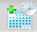
  - Night Shift 20:00 – 08:00
- If it is time to create a new Shift List, select the create new Shift List button from the bottom right
  - If it is not time to generate a new list, a message indicating the current Shift List is already in play will be displayed in the top center status bar
When the create a new Shift List button is clicked and the system moves to the forward page, all events in the current Shift List that are complete or disabled are removed from the current Shift List table and moved into the Shift List audit table. Once all forwarding events are validated and the Accept button is clicked on the forwarding page, the Shift List table is then populated with events for the current shift.
- The forwarding events page will be loaded indicating how many events are to be forwarded to the next Shift List
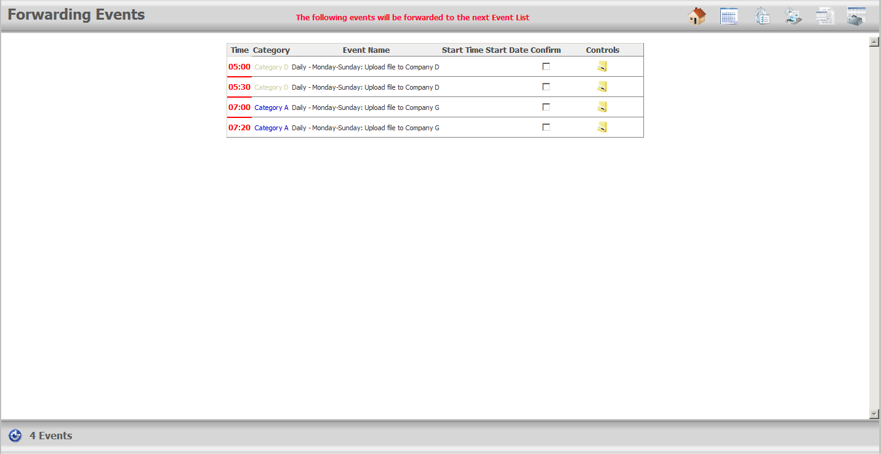
- From this page all forwarding events must be acknowledged by selecting the checkbox before the confirm button will appear in the bottom right corner – Comments are optional.
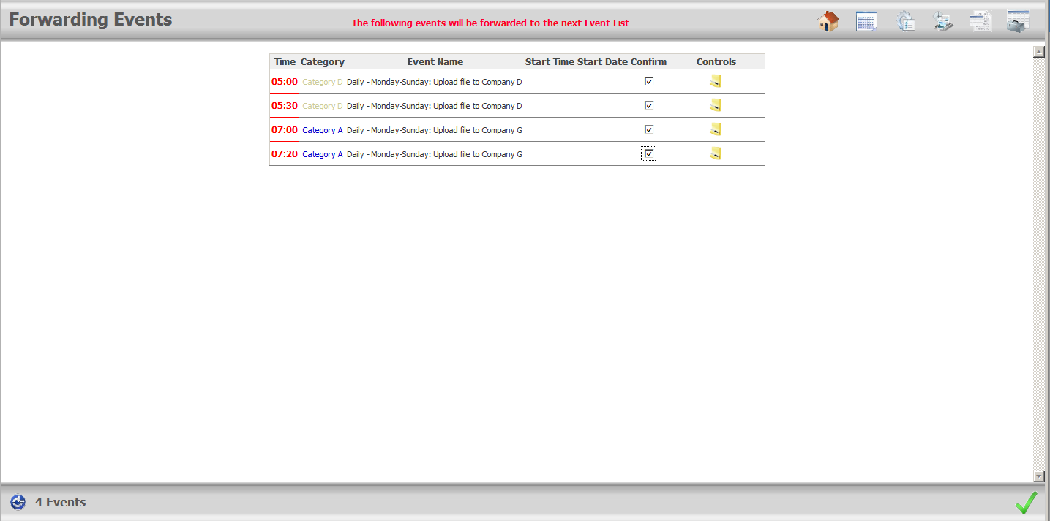


- Select the accept button – the green Check mark – to finish the new Shift List creation process
- The Shift List page will be loaded populated with the new Shift List data
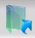
  - Save an Shift List
- From the Shift List page select the save Shift List button from the lower right corner
Pressing the enter key will also cause the Shift List to save
- All rows that have been edited will be saved to the database
  - A row is considered edited when its start date/time or end date/time boxes are changed
- Check the upper center status panel for a message indicating the date and time the Shift List was last saved at
The Shift List will automatically save changes to the database every 10 minutes
  - Add a Comment
- From the Shift List Page click the comment icon on the relevant row
- The comment window will open overtop the Shift List
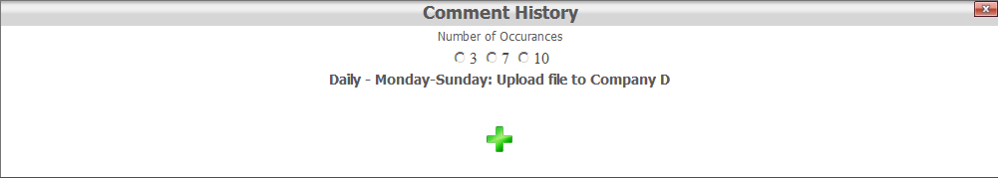
- Select the green cross icon at the bottom to add a new comment
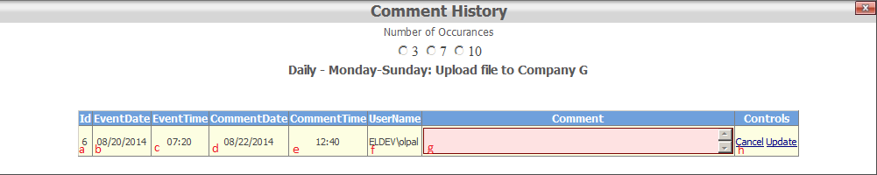
- The row currently being edited, in this case the row being added, is highlighted in yellow while the comment box is highlighted in red
- Additional information includes
  - Id of the event in the comment table
  - The date in which the event originally occurred on
  - The time in which the event originally occurred at
  - The date of the comment in question
  - The time of the comment in question
  - The Username of the person entering the comment (If Active Directory authentication and Kerberos security are configured)
  - The comment itself
  - Controls – Update to save, Cancel to cancel and edit
- Enter the necessary comment in the red text box under the comment column
- Select Update from the far right to save the event
- The window should now display the new comment
Comments that have been added within the last 12 hours by the same username that currently has the comment window opened will display an edit button – i.e. a user can only edit a comment that they have entered within the past 12 hours
  - Add a One Time Event
    - Select the Add onetime event button from the bottom right of the Shift List page
    - The below window will open
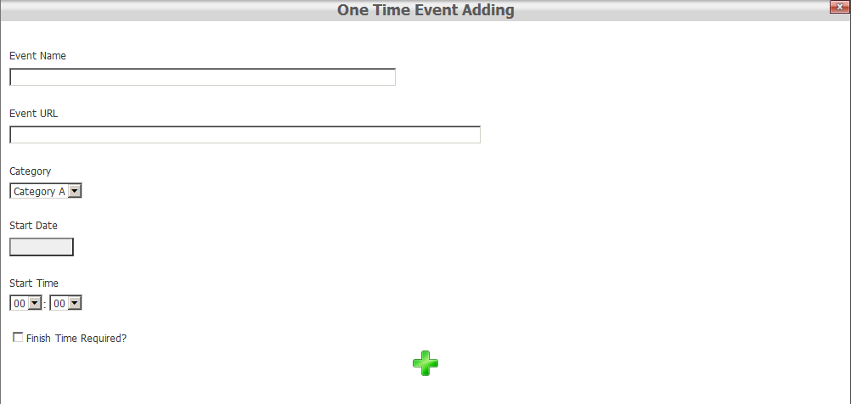
    - Fill in all relevant information, Event Name, Category, Start Date and Start Time are the required fields with URL and Finish Time Required being option
    - Ensure that the Start Date and Time fall within the current Shift List otherwise the event will not be added and a message will be displayed – see below
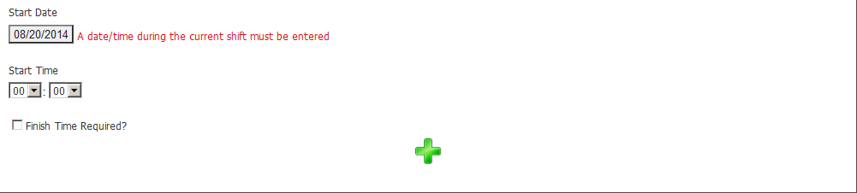
    - If the event was successfully added the form will clear itself, a message at the bottom will indicate the event has been added, and the status message on the main Shift List page will also indicate a one-time event has been added
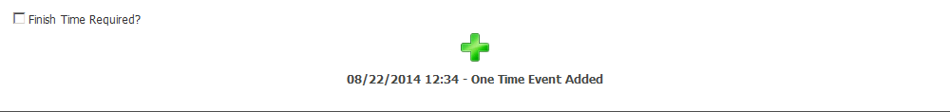
  - Disable/Enable an Event
- Locate the event that needs to be disabled
- Use the comment instructions to enter a comment relating to why the event is being disabled
A comment must be entered for an event within the past 60 minutes in order for the event to be disabled
- Select the disable button
- The event can take up to 15 seconds to disable, you will be unable to scroll the page will the disabling takes place
- To re-enable an event click the enable button, the event will be re-enabled within 15 - 30 seconds
  - Editing a Comment
    - Select the comment button from the row of the event that contains the comment to be edited
    - Select the number of occurrences – ensure the number selected is high enough to include the comment that you wish to edit. For example if the comment to be edited was the first of five entered on the current shift then selecting 7 or 10 will reveal it
    - Once the window is open, editable comments will appear with an edit link button in the controls column
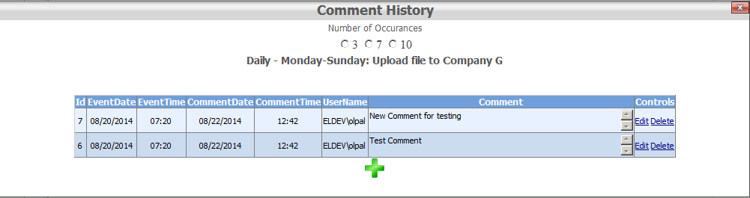
Comment will only be editable if they have been entered in the last 12 hours by the same user that has opened the Comment History window
    - Select the edit link button – A comment in edit mode will have the comment box highlighted in red with the rest of the row highlighted in yellow
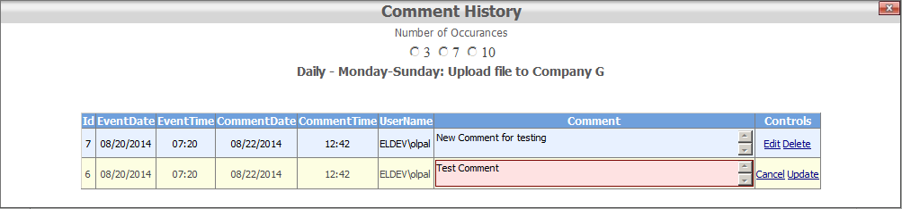
    - Select the update button to save changes to the comment window or the cancel button to return the comment to its original message
  - Update an Event
- Locate the row to make changes to
- Enter the Start time of the event in the start time box, this can be accomplished a number of way
  - Double clicking will automatically insert the current time
  - Typing in the time using the number keys in 4 digit format HH:MM, the colon will automatically insert itself after 2 numbers have been entered
  - Press the T key to insert the current time
- The start date should automatically be populated with the date the event was scheduled to start on, to change this date either
  - Double click the box to insert the current date
  - Type out the date in mm/dd/yyyy format
  - Press the T key to insert todays date
- Enter the end date and time the same way as the start date and time if applicable
- If anything abnormal occurred with the event, enter a comment using the instructions from this guide
- Save the Shift List, or wait for it to save automatically
The Tab key can be used to quickly navigate the lists time and date box components, while the T key will insert the current date/time in the appropriate box
  - View Comment Data
    - From the Shift List page, select the comment button from the row of the event to view the comments of that event
    - The comment window will open and look like the below image. The window displays the name of the event that comment data is being examined for, radio buttons to determine the number of occurrences to load (this is the number of records to load, NOT the number of days), and a green cross button to add a new comment.
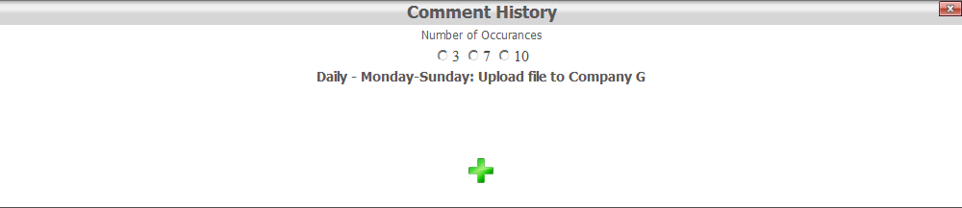
    - A new comment can be entered without selecting an occurrence first if so desired, otherwise select an occurrence and the comment information will load into a data gird
    - The data grid will display, from left to right, the ID of the comment as it appears in the comments table, the date and time that the event commented on was scheduled to occur, the date and time that the comment was entered, the name of the user who entered the comment, the comment itself, and relevant controls
  - View Performance Data
    - From the Shift List page, select the performance button from the row of the event to view the performance information for that event
    - The performance window will open and look like the below image. The window displays the name of the event that performance data is being examined for and radio buttons to determine the number of occurrences to load (this is the number of records to load, NOT the number of days)
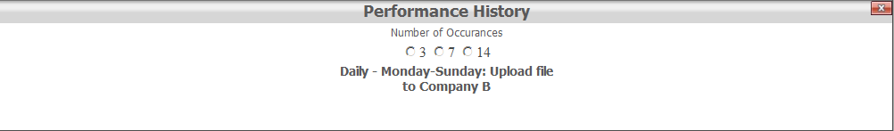
    - The data grid will display, from left to right the date and time that the event was scheduled to occur, the actual start date and time of the event, and if applicable, the end date time and duration. End date, time and duration are only present if the event in question requires a finish time.
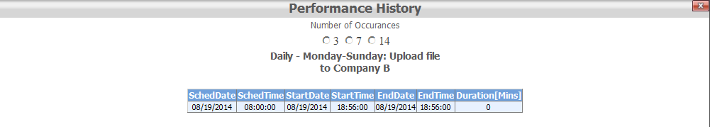
- Event Management Page - Top
  - Duplicate an Event
- Navigate to the Event Management Page
- Locate the event that is to be duplicated
- Select the duplicate button, this should redirect to the event creation page with the fields already populated with the details of the previous event and the status mode message at the top reading Current Mode: Event Duplication
- Make the necessary changes to the new duplicated event
- Select the save button, the green check mark, from the lower right corner
- The page should reload indicating the time the update was made in the lower left corner and the status mode message should now read Current Mope: Event Editing. This indicates that the event has been added to the database and can now be edited if necessary
- Close/Navigate away from the page
  - Delete an Event
- Navigate to the Event Management Page
- Locate the event to be deleted
- Click the delete button
- If the deletion was successful a message indicating so will be displayed in the top center status box, along with the ID of the event deleted
- If the event deletion failed, a message indicating so will be displayed in the top center status box. The event deletion failed most likely because the event is still present on the current Shift List
Only events that are NOT part of the current Shift List can be deleted
  - Disable/Enable an Event
Events disabled through the management page will NOT appear in future Shift Lists
- Navigate to the Event Management Page
- The check box under the Active column displays whether an event is active or not
Non-Active events will NOT be included in future Shift List; however, the event will NOT be deleted from the database either
- Select the Disable button
- The checkbox should disappear within 15 seconds, and the disable button will change to an enable button
Enabled Event
Disabled Event
- To re-enable event click the enable button, the event should re-enable within 15 seconds
  - Edit an Event
    - Navigate to the Event Management Page
    - Locate the event that is to be edited
    - Select the edit button, this should redirect to the event creation page with the fields already populated with the details of the previous event and the status mode message at the top reading Current Mode: Event Editing
    - Make the necessary changes to the existing event
    - Select the save button, the green check mark, from the lower right corner
    - The page should reload indicating the time the update was made in the lower left corner and the status mode message should now read Current Mope: Event Editing. This indicates that the changes have been saved to the database and can now be edited again if necessary
    - Close/Navigate away from the page
  - View an Event
    - Navigate to the Event Management Page
    - Locate the event that is to be viewed
    - Select the view button, the Event Creation Page will be loaded in a new window populated with the event information, however, all controls will be in read only mode
    - In view mode three additional controls appear in the bottom right corner to facilitate the viewing of Performance, Comment, and Audit data – See the Viewing Performance/Comment/Audit data sections later in this guide for more information
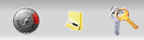
- Event Creation Page - Top
  - Create a New Event
- Navigate to the event Creation page
- Fields that require data in order for the event to be created are
  - Event Name – The name of the event
  - Category – The category the event falls under, selectable from a pre-entered list
  - Schedule – The schedule in which the event occurs in – See the section Understanding Event Scheduling if you are unsure about scheduling
  - Start Date – The start date of the event, depending on the schedule type this field is utilized differently
  - Start Time – The start time of the event
- Optional fields include
  - Event Documentation – This is an active URL to documentation describing the event
  - Event URL – This is an active web link, or mail to link, relating to the event
  - Finish Time Required – If this box is selected then a finish time/date box will appear on the Shift List for this event
  - Active – Indicates if the event should be created as active – default is yes
- Each of the fields will attempt to validate its data once focus on the component has been lost – if the fields do not validate, changes cannot be saved
- Once all relevant information has been filled out, select the green check from the bottom corner to save changes
- The page should reload in Current Mode: Event Editing, and a status update message in the lower left corner indicating changes were updated – If the page reloads with now status message in the bottom left corner, or the status message displayed has a date not equal to now, then it is likely there is a component on the page which is in an invalid state, correct the data and try again.
  - Understanding Event Scheduling
When determining the schedule for an event it is important to remember to schedule the event on the absolute date and time that the event should occur on and not the date time of the event relative to what shift it should occur on – the database has no concept of shifts, in regards to events
- There are 7 different types of scheduling
  - Daily – The Event occurs on 1 – 7 days of the week, every week, at the same time
    - Daily allows for the choice of multiple combinations of days of the week. For example, Mon, Tues, Wed or Mon, Wed, Fri, or Tues and Sat etc.
  - Weekly – The event occurs once, the same day/time every week
    - The Start Date determines the day of the week the event occurs on every week. For example selecting Tuesday December 17th 2013 (12/17/2013) as the Start Date means the event will occur at the Start Time specified every Tuesday of every week
  - Bi-Weekly – The event occurs once every two weeks on the same day/time
    - The Start Date determines the day of the week the event occurs on every second week. For example selecting Tuesday December 17th 2013 (12/17/2013) as the Start Date means the event will occur at the Start Time specified every second Tuesday starting with the start date – the next occurrence of this event would be Tuesday December 31st 2013 (12/31/2013)
  - Monthly – The event occurs once a month
    - Monthly allows for the choice of dates of the month 1-31 and last, indicating last of the month. It is important to recognize that events scheduled for the 31st will NOT appear in 30 day months and any event scheduled 27+ will not appear in February. The last option is used to specify the last day of the month no matter the date, therefore entering events with day dates from 28 – 31 is dangerous and should be used accordingly in regards to monthly events.
  - Quarterly – The event occurs once every three months
    - The start time will determine when the event reoccurs every 3 months. If an event is entered with a date of January 1 2013 then this event will occur every January, April, July, October on the 1st at the specified start time
  - One-Time – The event occurs only once
    - The start date determines the date in which the event will occur, with the start time determining the time
  - Frequent Reoccurrence – The event re-occurs frequently in a predictable pattern
    - Frequent Reoccurrence allows for the specification of First, Second, Third, Fourth or Last Sunday through Saturday of every month. Some months have five occurrences of a particular day, for example December 2013 has Five Sundays, Mondays, and Tuesdays; therefore, it is important to ensure the right reoccurrence method is selected; two events one configured for the last Tuesday of the month and another configured for the Fourth Tuesday of the month would occur in different weeks in December 2013, but would occur in the same week in January 2014.
  - View and Interpret Audit Data
    - Navigate to the Event Management Page
    - Locate the event in which you wish to examine the Audit data of
    - Select the view button, the Event Creation Page will be loaded in a new window populated with the event information, plus the three additional controls in the bottom right corner
    - Select the audit button – the performance window will then open
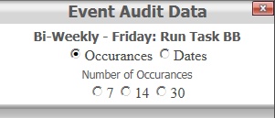
    - The Event Audit Data window displays the name of the event currently being examined along with radio buttons to load by number of occurrences or dates. Number of occurrences will load the number listed number of records from the database starting with the most recent.
    - Select a number of occurrences or select the dates radio button and input a start and end date (inclusive)
    - The results will then populate into a data grid
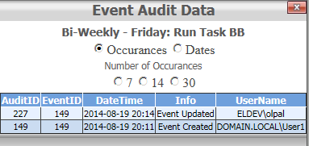
    - The Audit data grid displays the ID of the entry in the Audit table, the ID of the event which the audit entry relates to, an audit message, and the username of the user responsible for the generation of the entry.
    - Select the red X button to close out the window or one of the radio buttons to perform another query
  - View and Interpret Comment Data
    - Navigate to the Event Management Page
    - Locate the event in which you wish to examine the Comment data of
    - Select the view button, the Event Creation Page will be loaded in a new window populated with the event information, plus the three additional controls in the bottom right corner
    - Select the comment button – the performance window will then open
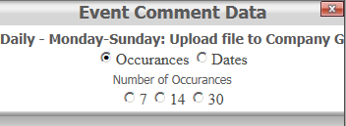
    - The Event Comment Data window displays the name of the event currently being examined along with radio buttons to load by number of occurrences or dates. Number of occurrences will load the number listed number of records from the database starting with the most recent.
    - Select a number of occurrences or select the dates radio button and input a start and end date (inclusive)
    - The results will then populate into a data grid
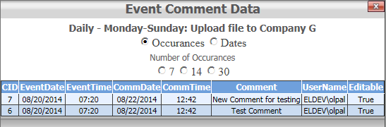
    - The Comment data grid displays, the ID of the comment as it appears in the comments table, the date and time that the event commented on was scheduled to occur at, the date and time that the comment was entered, the comment itself and the name of the user who entered the comment
    - Select the red X button to close out the window or one of the radio buttons to perform another query
  - View and Interpret Performance Data
    - Navigate to the Event Management Page
    - Locate the event in which you wish to examine the Performance data of
    - Select the view button, the Event Creation Page will be loaded in a new window populated with the event information, plus the three additional controls in the bottom right corner
    - Select the performance button – the performance window will then open
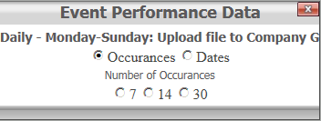
    - The Event Performance Data window displays the name of the event currently being examined along with radio buttons to load by number of occurrences or dates. Number of occurrences will load the number listed number of records from the database starting with the most recent.
    - Select a number of occurrences or select the dates radio button and input a start and end date (inclusive)
    - The results will then populate into a data grid
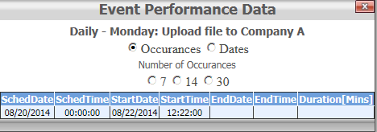
    - The Performance data grid displays the date and time that the event was scheduled for, the actual date and time that the event started at, and if the event requires a finish time, the end date time and duration in minutes
    - Select the red X button to close out the window or one of the radio buttons to perform another query
- Event Reporting Page - Top
  - View a Past Shift List from Audit Data
    - Navigate to the Event Reporting Page
    - The IMPORTANT option to select here is the Event Audit check box – This ensures that the EventList_Audit table is queried rather than creating an Shift List for the specified date
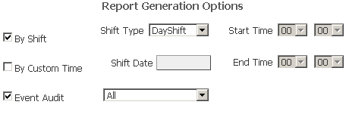
    - Select By shift to select between DayShift and NightShift or Select By Custom Time if you wish to enter your own Start/End dates and times
    - Enter the Shift Date (If By Shift is selected) and choose the Shift Type DayShift/NightShift
    - Click the Create Report button in the bottom right or press the enter key and the data gird will be populated like the image below
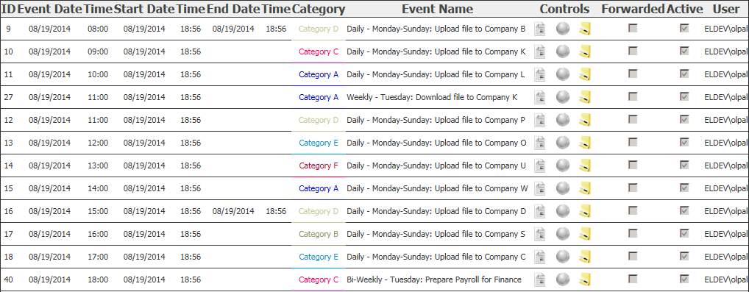
If the Event Audit checkbox is selected and a future date is input, no data will be displayed
    - The data grid will display information relating to all events that were scheduled to occur between the provided report start/end times. Information includes the ID of the event, the scheduled date and time of the event, the actual start date and time of the event, the end date and time (if applicable), the event category, the event name, controls (URL and Doc links will only be displayed if the event has that corresponding link; the comment window will be displayed regardless of if a comment was entered during the report start/end times), the active status of the event during the report times, and finally the username of the user who entered the event information.
    - Selecting the comment button will bring up the comment window for that event, clicking the get comments button will get all comments that occurred for that event between the provided report start and end times
  - View a Past or Future Shift List
    - Navigate to the Event Reporting Page
    - Ensure that the Event Audit check box is NOT checked – This ensures that the system will create a report list for the provided times rather than querying the eventlist_audit table
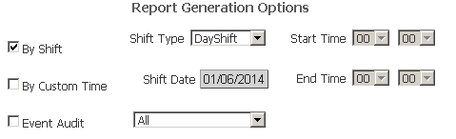
    - Select By shift to select between DayShift and NightShift or Select By Custom Time if you wish to enter your own Start/End dates and times
    - Enter the Shift Date (If By Shift is selected) and choose the Shift Type DayShift/NightShift
    - Click the Create Report button in the bottom right or press the enter key and the data gird will be populated like the image below
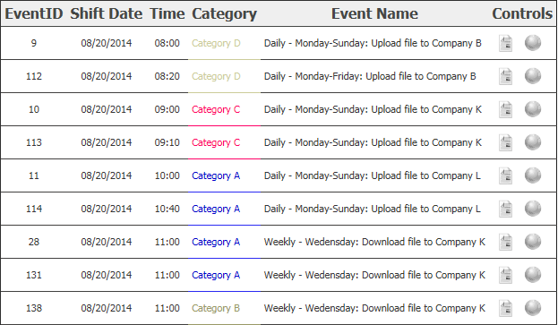
    - The data grid will display information relating to all events that are/were scheduled to occur between the provided report start/end times. Information includes the ID of the event, the scheduled date and time of the event, the event category, the event name, and controls (URL and Doc links will only be displayed if the event has that corresponding link

